3.2 covalent bond
Name: ____________________ Class: ____________________ Due date:
Name: ______________ Class: ______________ Due date:
1. The diagrams show the electron arrangements in the atoms of four elements.
Which element does not form a covalent bond? （ ）
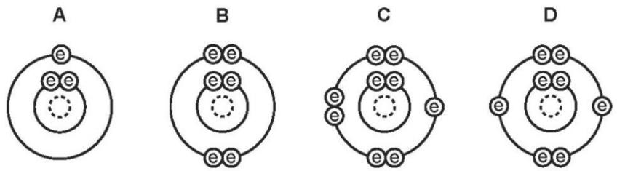
2.Electrons from each element are shared by both of the elements in a compound.
Which compound matches this description? （ ）
A lead bromide B sodium chloride C water D zinc oxide

3. Which statement about the bonding in a molecule of water is not correct? （ ）
A Both hydrogen and oxygen have a noble gas configuration of electrons.
B Each hydrogen shares its one electron with oxygen.
C Oxygen shares one of its own electrons with each hydrogen.
D Oxygen shares two of its own electrons with each hydrogen.

4.In the following diagrams, X and Y are atoms of different elements.
Which diagram correctly shows the arrangement of outer electrons in a molecule of methane( CH₄ )? （ ）
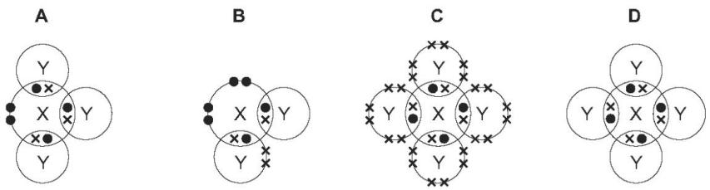

5.Which dot- and- cross diagram shows the outer shell electron arrangement in a molecule of carbon dioxide? （ ）
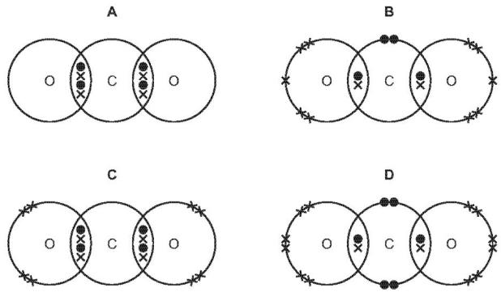
6.Which row describes the formation of single covalent bonds in methane? （ ）
A | atoms share a pair of electrons | both atoms gain a noble gas electronic structure
B | atoms share a pair of electrons | both atoms have the same number of electrons in their outer shell
C | electrons are transferred from one atom to another | both atoms gain a noble gas electronic structure
D | electrons are transferred from one atom to another | both atoms have the same number of electrons in their outer shell

7. Sulfur dichloride, SCl₂, is a covalent compound. It has the structure Cl - S - Cl
Water H₂O is also a covalent compound, It has the structure H=O=H
Draw a dot - and - cross diagram to show the electron arrangement in a molecule of sulfur dichloride. Show outer shell electrons only.
SCl₂ | H₂O

8. This question compares giant and simple molecular structures.
(a) State one property that is different between giant molecular and simple molecular substances. [1]

